Circuit Breaker Pattern
A circuit breaker pattern is named after (and works like) the electrical circuit breaker / power trip you see in homes and labs. Circuit Breaker is used in microservices to stop a system from failing again and again.
Normal state = Power ON (Closed circuit)
- Electricity flows normally.
- In software: Service A calls Service B normally.
Failures happen (Overload)
- Service B becomes slow or down.
Service A gets errors/timeouts repeatedly. • After many failures (threshold), Circuit Breaker trips.
• It stops sending requests to Service B for some time.
• Instead, it returns a quick reply like: (fallback method)
- “Payment temporarily unavailable” (default message)
- or cached old result (saved response)
Half-Open state
- After waiting, it sends few test requests.
- If test succeeds → it closes (normal calls start again)
- If test fails → it opens again (waits longer)

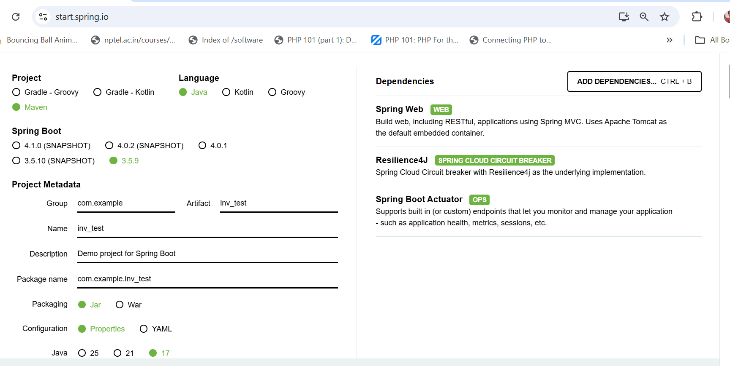

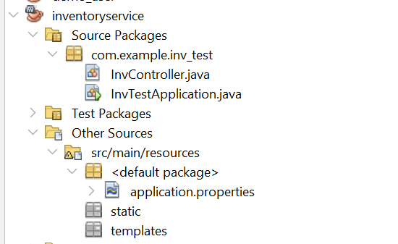
InvTestApplication.java
package com.example.inv_test;

import org.springframework.boot.SpringApplication;
import org.springframework.boot.autoconfigure.SpringBootApplication;
import org.springframework.context.annotation.Bean;
import org.springframework.web.client.RestTemplate;

@SpringBootApplication
public class InvTestApplication {

public static void main(String[] args) {
SpringApplication.run(InvTestApplication.class, args);
}

@Bean
public RestTemplate restTemplate() {
return new RestTemplate();
}
}

Pom.xml
<project xmlns="http://maven.apache.org/POM/4.0.0"
xmlns:xsi="http://www.w3.org/2001/XMLSchema-instance"
xsi:schemaLocation="http://maven.apache.org/POM/4.0.0
https://maven.apache.org/xsd/maven-4.0.0.xsd">

<modelVersion>4.0.0</modelVersion>
<groupId>com.example</groupId>
<artifactId>inventoryservice</artifactId>
<version>0.0.1-SNAPSHOT</version>
<name>inventoryservice</name>
<description>Inventory Service with Resilience4j</description>

<parent>
<groupId>org.springframework.boot</groupId>
<artifactId>spring-boot-starter-parent</artifactId>
<version>3.2.5</version>
<relativePath/>
</parent>

<properties>
<java.version>17</java.version>
</properties>

<dependencies>
<!-- Spring Web -->
<dependency>
<groupId>org.springframework.boot</groupId>
<artifactId>spring-boot-starter-web</artifactId>
</dependency>

<!-- Resilience4j Circuit Breaker -->
<dependency>
<groupId>io.github.resilience4j</groupId>
<artifactId>resilience4j-spring-boot3</artifactId>
<version>2.2.0</version>
</dependency>

<!-- AOP is REQUIRED for @CircuitBreaker to work -->
<dependency>
<groupId>org.springframework.boot</groupId>
<artifactId>spring-boot-starter-aop</artifactId>
</dependency>

<!-- Spring Boot Actuator -->
<dependency>
<groupId>org.springframework.boot</groupId>
<artifactId>spring-boot-starter-actuator</artifactId>
</dependency>

<!-- Test -->
<dependency>
<groupId>org.springframework.boot</groupId>
<artifactId>spring-boot-starter-test</artifactId>
<scope>test</scope>
</dependency>
</dependencies>

<build>
<plugins>
<plugin>
<groupId>org.springframework.boot</groupId>
<artifactId>spring-boot-maven-plugin</artifactId>
</plugin>
</plugins>
</build>
</project>

InvController.java

package com.example.inv_test;
import io.github.resilience4j.circuitbreaker.annotation.CircuitBreaker;
import org.springframework.beans.factory.annotation.Autowired;
import org.springframework.web.bind.annotation.GetMapping;
import org.springframework.web.bind.annotation.RestController;
import org.springframework.web.client.RestTemplate;

@RestController
public class InvController {

@Autowired
private RestTemplate restTemplate;

private static final String SHIPPING_SERVICE_URL = "http://localhost:8082/shipping";

@GetMapping("/check-inventory")
@CircuitBreaker(name = "shippingService", fallbackMethod = "fallbackForShipping")
public String checkInventory() {
return restTemplate.getForObject(SHIPPING_SERVICE_URL, String.class);
}

// ✅ Correct fallback signature for no-argument method
public String fallbackForShipping(Throwable throwable) {
System.out.println("⚠️ Fallback triggered. Cause: " + throwable);
return "Shipping Service is currently unavailable. Please check again later.";
}
}

Application.properties for inv_test
spring.application.name=inv_test
server.port=8080

resilience4j.circuitbreaker.instances.shippingService.registerHealthIndicator=true
resilience4j.circuitbreaker.instances.shippingService.slidingWindowSize=5
resilience4j.circuitbreaker.instances.shippingService.minimumNumberOfCalls=1
resilience4j.circuitbreaker.instances.shippingService.failureRateThreshold=50
resilience4j.circuitbreaker.instances.shippingService.waitDurationInOpenState=10s
resilience4j.circuitbreaker.instances.shippingService.recordExceptions=org.springframework.web.client.ResourceAccessException,java.lang.Exception

Assume shipping service is not started at this stage

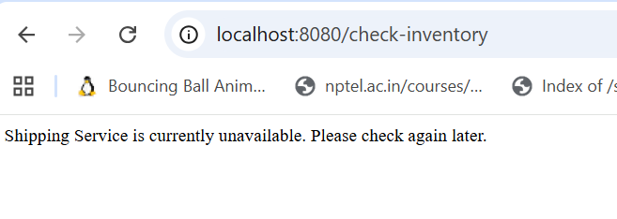
prints to the console/Output window of NetBeans/terminal, not to the browser.
Second Service
Choose the dependency spring web and actuator for the shipping service in start.spring.io and bundle it as project.
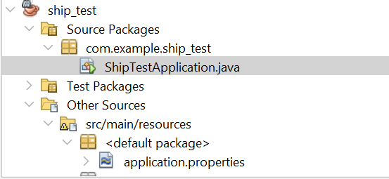
ShipTestApplication.java
package com.example.ship_test;

import org.springframework.boot.SpringApplication;
import org.springframework.boot.autoconfigure.SpringBootApplication;
import org.springframework.web.bind.annotation.GetMapping;
import org.springframework.web.bind.annotation.RestController;

@SpringBootApplication
public class ShipTestApplication {

public static void main(String[] args) {
SpringApplication.run(ShipTestApplication.class, args);
}

@RestController
class ShippingController {
@GetMapping("/shipping")
public String getShippingStatus() {
return "Shipping Service is working fine!";
}
}
}
Application.properties for Shipping service
spring.application.name=ship_test
server.port=8082

Now Shipping Service started
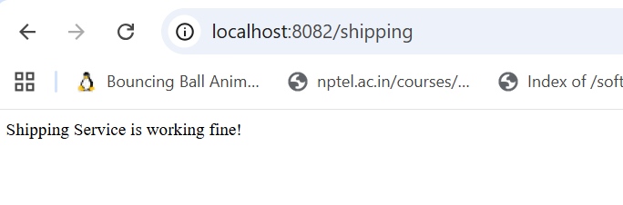

Stop the Shipping Service now and give the below:

Localhost:8080/check-inventory
